SIMPLE TRANSPORT POOL & RIDE SHARE BOARD
@CREATIVITY THINK (9483175986/7019689991)

ABSTRACT:
Simple Transport Pool & Ride Share Board is a web-based application designed to facilitate shared commuting for college students, office employees, and local neighborhood residents. The platform allows users to post ride offers or requests, search for compatible rides, coordinate via in-app group chat, and rate co-riders after completion. Administrators can verify users, monitor groups and chats, handle abuse reports, and generate analytics on popular routes, ride counts, and environmental impact such as CO2 savings. Developed with Django and Django REST Framework for backend processing and React with Redux and Socket.io for real-time frontend interactions, the system ensures safe, efficient, and collaborative ride sharing..

INTRODUCTION OF THE PROJECT:
Commuting individually is often inefficient, expensive, and environmentally unfriendly. Existing ride-sharing solutions may lack real-time coordination, user verification, or detailed analytics for group management. The Simple Transport Pool & Ride Share Board addresses these issues by providing a centralized platform for posting rides, filtering by route and time, coordinating via chat, and tracking ride completion and ratings. Administrators gain insights into popular routes, ride frequency, and user activity while ensuring safe and verified participation, promoting a sustainable and collaborative commuting experience..

PROJECT OBJECTIVES:

• Provide a platform for posting and searching ride offers and requests
• Enable real-time communication via in-app group chat
• Implement route and time-based filtering for ride matching
• Allow users to mark rides as completed and rate co-riders
• Verify users and manage account authenticity
• Monitor group activities and handle abuse reports
• Offer analytics dashboards for route popularity, ride counts, and environmental impact
• Generate monthly reports including CO2 saved estimates
• Promote sustainable, cost-effective, and social commuting solutions

PROBLEM OF THE STATEMENT:
Individual commuting increases traffic congestion, expenses, and carbon emissions. Existing ride-sharing methods lack a dedicated verification system, real-time coordination, and analytics to track efficiency or environmental impact. Users face difficulty finding compatible rides and managing communication, while administrators struggle to monitor group safety and user behavior. This project addresses these challenges by providing a structured, secure, and data-driven platform for collaborative commuting..

MOTIVATION OF THE PROJECT:
• To reduce individual commuting costs and traffic congestion
• To provide a verified and secure ride-sharing environment
• To encourage environmentally sustainable travel by tracking CO2 savings
• To facilitate efficient coordination among users through real-time chat
• To monitor ride-sharing trends and popular routes via analytics
• To provide administrators with tools to detect and handle misuse
• To improve user satisfaction and trust through rating and feedback
• To enhance the social and collaborative experience of commuting

BLOCK DAIGRAM OF PROJECT:

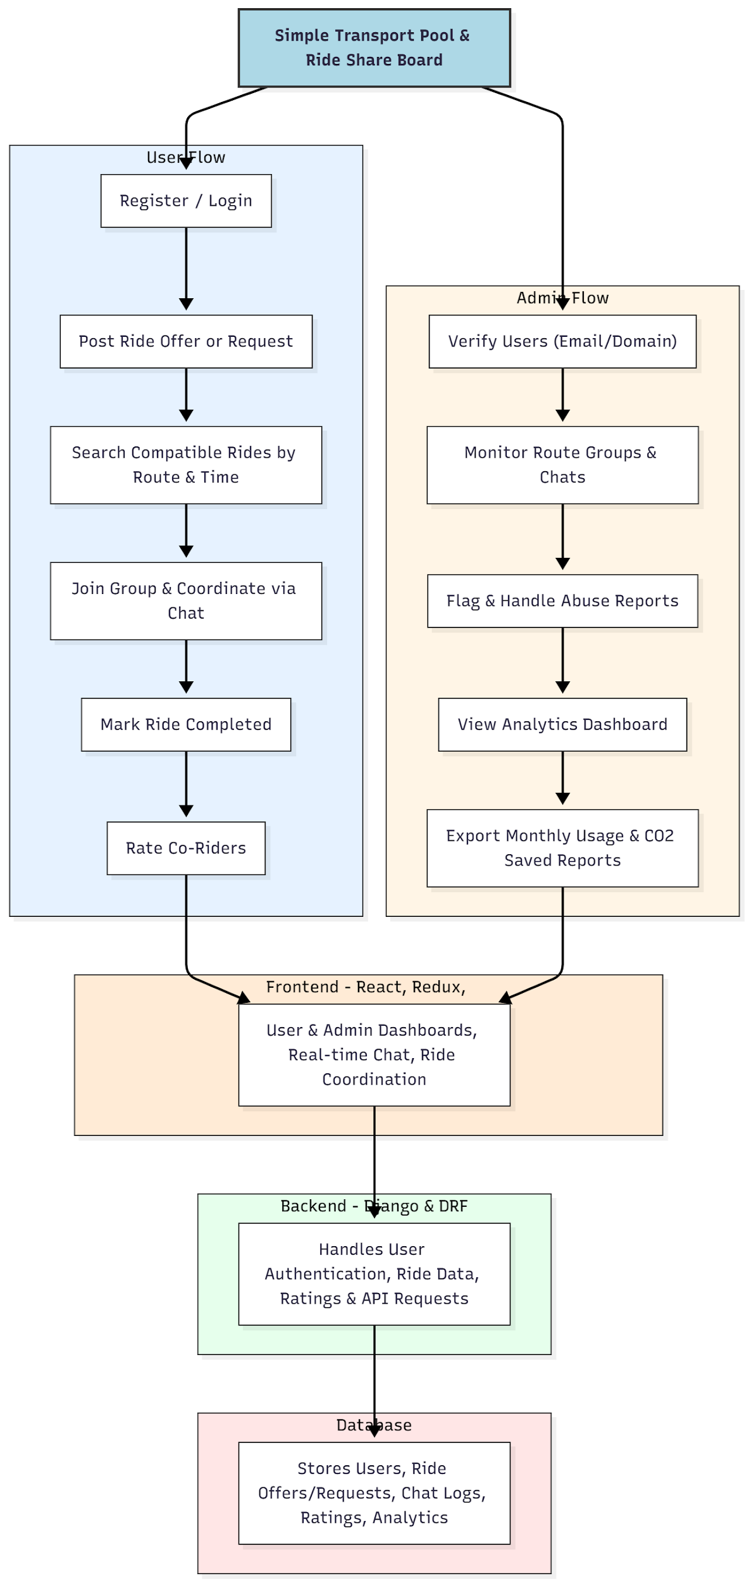

WORKING OF THE PROJECT:
Users begin by registering and posting ride offers or requests specifying route, time, and available seats. The platform matches compatible rides based on filters, and users can join groups to coordinate trips via real-time chat. Upon completing rides, users mark rides as completed and provide ratings for co-riders. Administrators verify new users, monitor ride groups and chats, handle abuse reports, and track analytics such as ride counts, route popularity, and estimated CO2 saved. All interactions are stored in the database, ensuring accurate record-keeping and efficient reporting..

SOFTWARE REQUIREMENT:
- Backend:
  - Python 3.x
  - Django
  - Django REST Framework
  - SQLite/PostgreSQL
- Frontend:
  - Node.js and npm
  - React.js
  - Axios
- Development Tools:
  - Visual Studio Code
  - Postman (for testing APIs)
  - Git/GitHub (for version control)
- Server/Deployment (Optional):
  - Gunicorn, Nginx, or Heroku/AWS for hosting

ADVANTAGES OF THE PROJECT:

• Promotes collaborative and cost-effective commuting
• Enables secure and verified user participation
• Real-time coordination via in-app chat
• Provides ride completion tracking and rating for accountability
• Dashboard analytics to monitor popular routes and usage
• Supports environmental sustainability via CO2 tracking
• Reduces individual commuting costs and traffic congestion
• Enhances social interaction and group collaboration

APPLICATIONS OF THE PROJECT:
• College and university student ride sharing
• Corporate or office commuters
• Neighborhood or local community transport coordination
• Carpooling and environmental sustainability initiatives
• Event or conference ride coordination

REFERENCES:

- Django REST Framework Documentation — Django Software Foundation. Django Documentation. Available: https://docs.djangoproject.com/
- Django REST Framework. DRF Documentation. Available: https://www.django-rest-framework.org/
- React. React Official Documentation. Available: https://reactjs.org/docs/getting-started.html
- Redux. Redux Documentation. Available: https://redux.js.org/introduction/getting-started
- PostgreSQL Global Development Group. PostgreSQL Documentation. Available: https://www.postgresql.org/docs/
- MySQL. MySQL Reference Manual. Available: https://dev.mysql.com/doc/
- Git. Git Documentation. Available: https://git-scm.com/doc
- Node.js. Node.js Documentation. Available: https://nodejs.org/en/docs/
- Axios. Axios Documentation. Available: https://axios-http.com/docs/intro
- Socket.io Documentation – https://socket.io/docs/

